



Image Classification

LAB MANUAL

Disclaimer: The content is curated from online/offline resources and used for educational purpose only
To develop a CNN model to classify images of Organic or Recyclable

Objective:
Develop a Convolutional Neural Network (CNN) model to classify images into two categories: 'Organic' and 'Recyclable.' The system will analyze and categorize waste images, aiding in efficient waste management and promoting sustainability practices.

Problem Statement:
- Collect and preprocess a dataset of labeled images categorized as "Organic" and "Recyclable."
- Design a CNN architecture tailored to extract features from waste images, including spatial patterns and textures.
- Train the CNN model on the preprocessed dataset using a training-validation split.
- Evaluate the effectiveness of the model in reducing manual waste segregation efforts.
- Demonstrate how the model can support recycling initiatives and improve environmental sustainability.

Equipment Required:
- Python installed with Jupyter Notebook / VS Code / Google Colab
- Libraries: tensorflow or keras, numpy, matplotlib, opencv-python, sklearn
- Dataset of labeled images categorized into Organic and Recyclable classes, stored in structured directories (e.g., dataset/organic/ and dataset/recyclable/)
- Image pre-processing tools (OpenCV or TensorFlow/Keras image utilities)

Prerequisites:
- Basic knowledge of Python programming
- Understanding of image data representation (pixels, channels, RGB format, etc.)
- Familiarity with Convolutional Neural Networks (CNNs) and their components (convolution layers, pooling, activation functions, etc.)

Procedure:
Step 1: Import required libraries
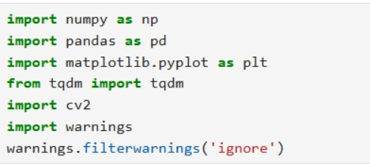
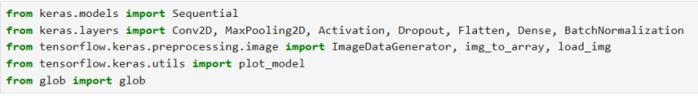
Step 2: Load Dataset
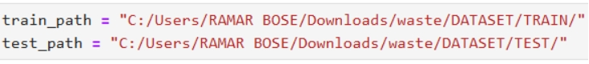
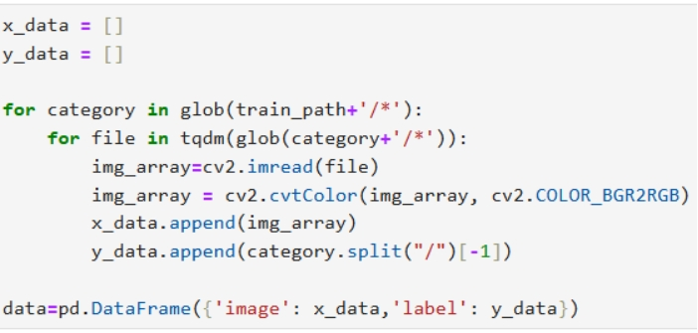
Step 3: Collections Count
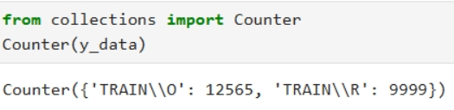
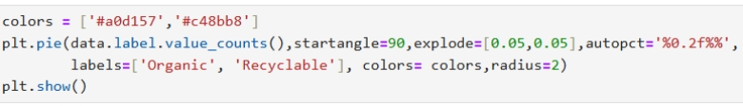
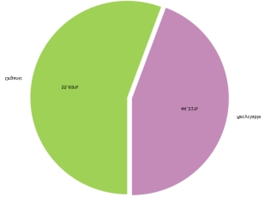
Step 4: Show data
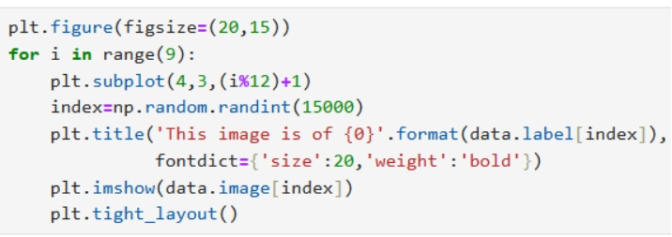
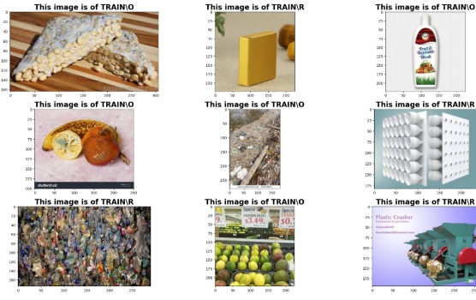

Step 5: Scale the data for better performance
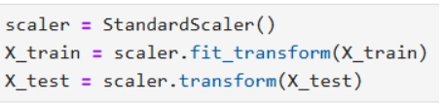
Step 6: Find number of classes in Data
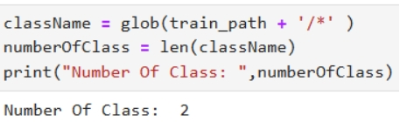
Step 7: Build the CNN Model
  - Initialize the model
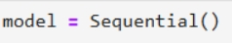
  - Convolution, Activation and Pooling layers
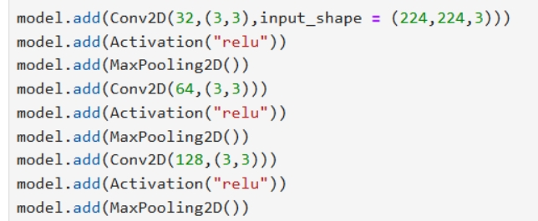
  - Flatten, Dropout and output layers
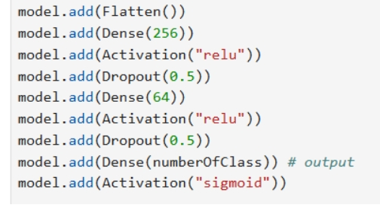
  - Compile the model
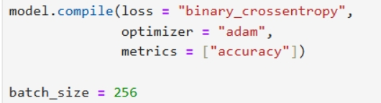

Step 8: Model Summary
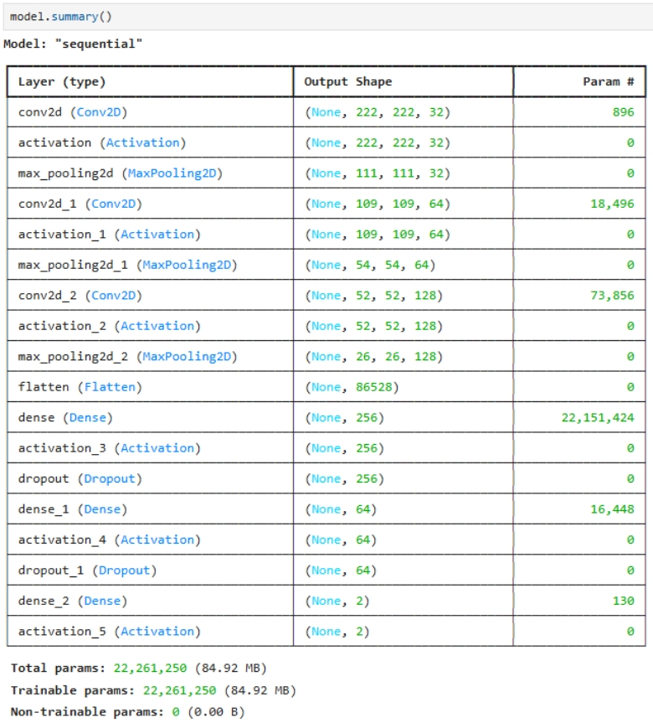

Step 9: Normalization
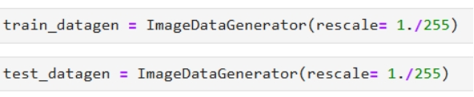
Step 10: Train and Test data generation
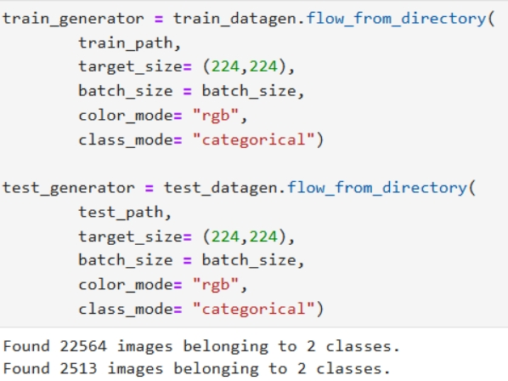
Step 11: Train the Model
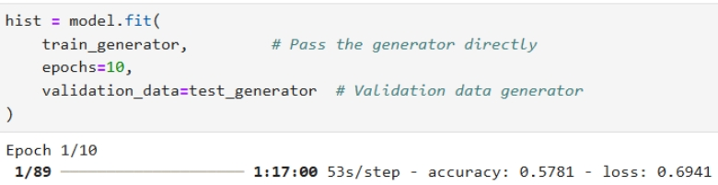
Running until 10th epoch.

Step 12: Plot Training Accuracy
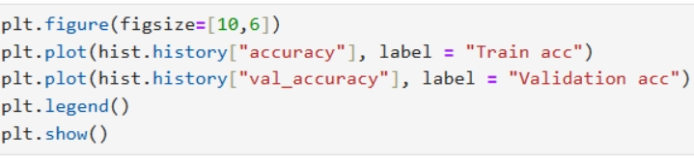
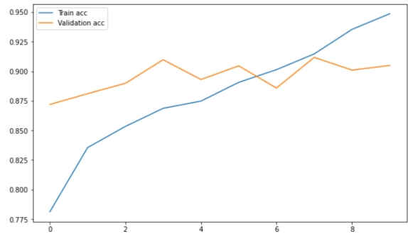

Step 13: Plot Loss
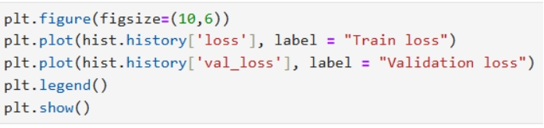
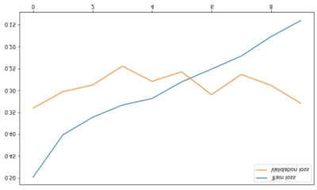

Step 14: Model Prediction
